小图=原子之间，大图（分层）更多物理作用，预测分子某能量

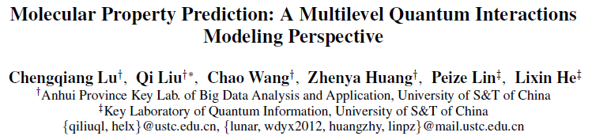

Traditional: density functional theory (DFT) in physics 费时

machine learning, complex inherent quantum interactions of molecules 未解决

MGCN, a generalizable and transferable Multilevel Graph Convolutional neural Network

represent each molecule as a graph to preserve its internal structure.

hierarchical graph neural network

extracts features from the conformation and spatial information followed by the multilevel interactions.

multilevel overall representations can be utilized to make the prediction.

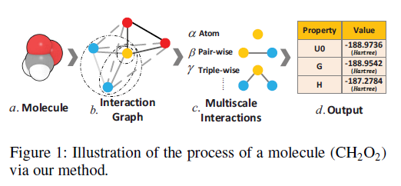

Network Architecture (three parts)

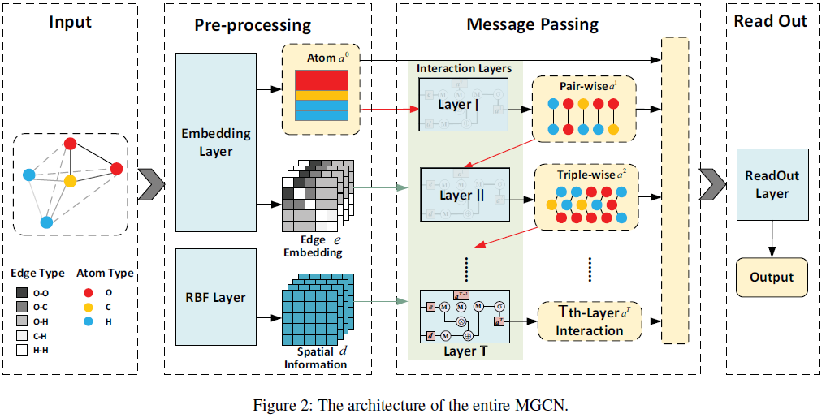

Embedding Layer

The initial input is a graph which consists of a list of atoms and a Euclidean distance matrix of the molecules.

The preprocessing part includes embedding layer and

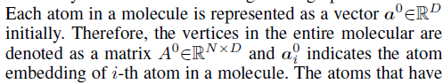

Radial Basis Function (RBF) layer.



The embedding layer generates atom and edge embeddings while Radial Basis Function (RBF) layer converts the distance matrix to a distance tensor.

Interaction Layer

The next part of MGCN are several interaction layers that aim to learn different node representations in different levels.

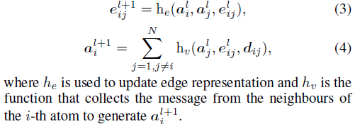





Readout Layer

The last phase is the readout layer that outputs the final result.

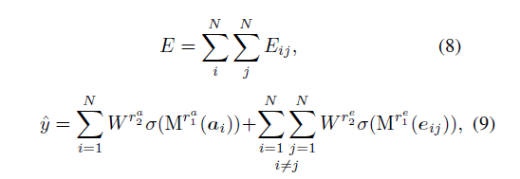

Abstract

Predicting molecular properties (e.g., atomization energy)

is an essential issue in quantum chemistry, which could

speed up much research progress, such as drug designing

and substance discovery. Traditional studies based on density

functional theory (DFT) in physics are proved to be

time-consuming for predicting large number of molecules.

Recently, the machine learning methods, which consider

much rule-based information, have also shown potentials for

this issue. However, the complex inherent quantum interactions

of molecules are still largely underexplored by existing

solutions. In this paper, we propose a generalizable and

transferable Multilevel Graph Convolutional neural Network

(MGCN) for molecular property prediction. Specifically, we

represent each molecule as a graph to preserve its internal

structure. Moreover, the well-designed hierarchical graph

neural network directly extracts features from the conformation

and spatial information followed by the multilevel interactions.

As a consequence, the multilevel overall representations

can be utilized to make the prediction. Extensive experiments

on both datasets of equilibrium and off-equilibrium

molecules demonstrate the effectiveness of our model. Furthermore,

the detailed results also prove that MGCN is generalizable

and transferable for the prediction.